I Laksa-it-a-lot Soup
Inspired by


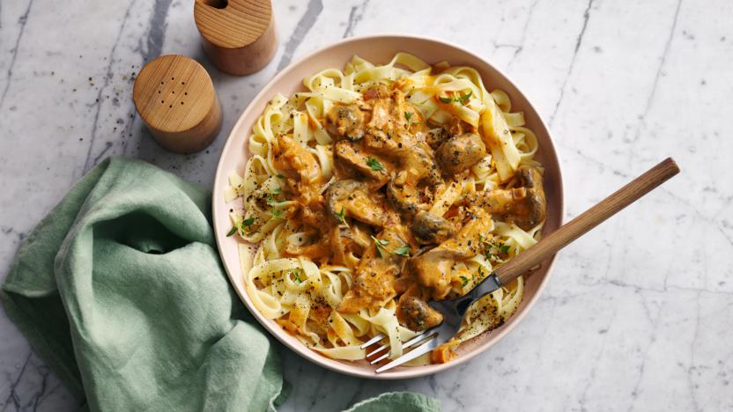
DID YOU KNOW?
“FUN FACT ABOUT THE SPICE BLEND!”

Ingredients
3 noodle nests
150g closed cup mushrooms
1 bell pepper
2 tsp lime juice
1 tbsp ginger puree.. lemongrass?
1 tin of light coconut milk
Spice blend ????
1 vegetable stock
3 tbsp peanut butter
2 spring onions
25g of salted peanuts
25ml soy sauce
Nutrition – Total / Per Serving
Calories: 800kcal / 400kcal
Carbohydrates: 300g / 150g
Protein: 80g / 40g
Fat: 60g / 30g
Fibre: 4g / 2g
Sugar: 3g / 1.5g






Good for:

Star Rating:




Method

Step 1 - Preparation
Boil the kettle (for noodles).
Slice the mushrooms and pepper.
Prepare the noodle nests according to package instructions with the boiling water.
Once the noodles are cooked, drain and run under cold water. Place in a bowl and set aside for later.

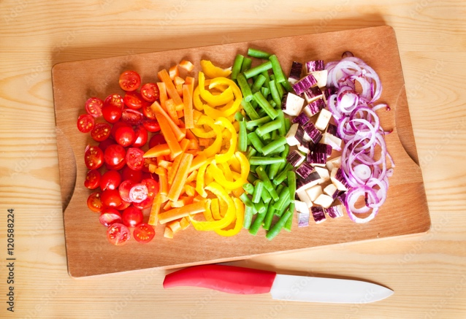
Step 2 – Make the Flavour
Place the saucepan back on heat and put in a splash of oil.
Add the mushrooms and pepper, cook until softened (~3 mins).
Stir in the SPICE BLEND and ginger puree.
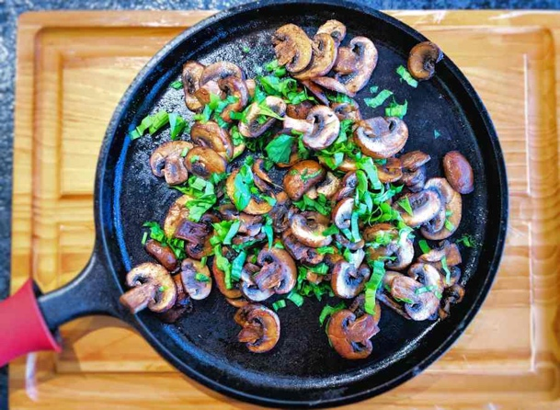
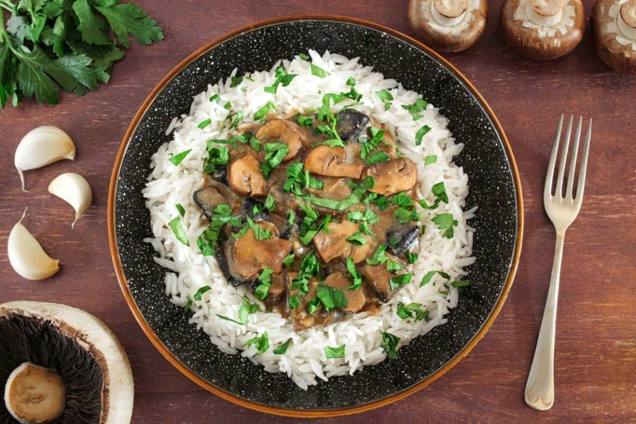
Step 4 – Bring it Together
Add the noodles from before to the saucepan, heat until hot.
Stir in the soy sauce and lime juice.

Serve into bowls and sprinkle the crushed peanuts on top.

Enjoy!
Step 3 – Simmer & Make it Saucy
Pour in the coconut milk and vegetable stock paste.
Bring to a boil, then lower the heat before adding in the peanut butter. Mix until well combined.
Simmer for ~4 min.

Crush the peanuts into small pieces.

